Bipedal Humaoid Robot

Documentation of CAD Creation and 3D Printing

Portland State University

Agile and Adaptive Robotics Laboratory

Contents

Designing the CAD Parts 2

Ilium 2

Femoral Head and Ball 2

3D Printing 2

Printing the Ilium: 2

Trial 1 2

Other Ideas 2

*Printing the Ilium Cover* 3

Printing the Femoral Head and Ball 4

# Designing the CAD Parts

## Ilium

## Femoral Head and Ball

## Sacrum

Plotting OpenSim4.0 Sacrum Points in Solidworks

1. Log into PSU Lab Solidworks
2. Open excel file for points
3. Convert them to mm filling in the first 3 columns
4. Save as ‘Formatted Text’ Space delimited
5. Open in the .prn file in notepad
6. Save as a .txt file
7. Select SolidWorks AddIns and Click ‘ScanTo3D’
8. Press ‘File’ -> ‘Open’
9. Select file type ‘ScanTo3D Point Cloud Files’’
10. Find .Txt Document File
11. Press Open
12. Confirm length is correct by measuring

# 3D Printing

## Printing the Ilium:

### Trial 1

Printed 2 times and failed

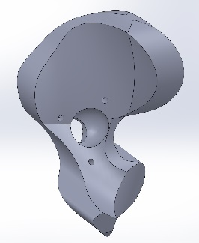



The print failed twice at the overhang where the plastic lifted up and the extruder caught onto it and pulled part off the bed:

### Other Ideas

1. Change the angle at which the part prints
   1. Add fillets
2. Split the part in 2 pieces and print.
   1. 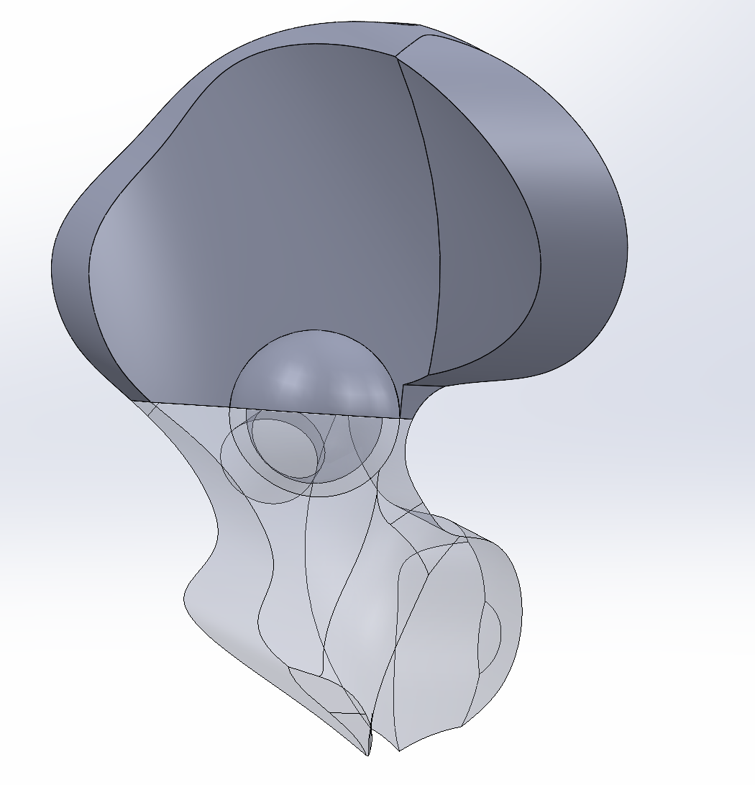
   2. This design allows the 2 pieces to connect together with the ball placed inside without the need for a cover, however, we are struggling to find the best way to connect the 2 pieces together since cross sectional area
   3. Another idea is to have the 2 piece ilium + the cover to hold everything together

## *Printing the Ilium Cover*

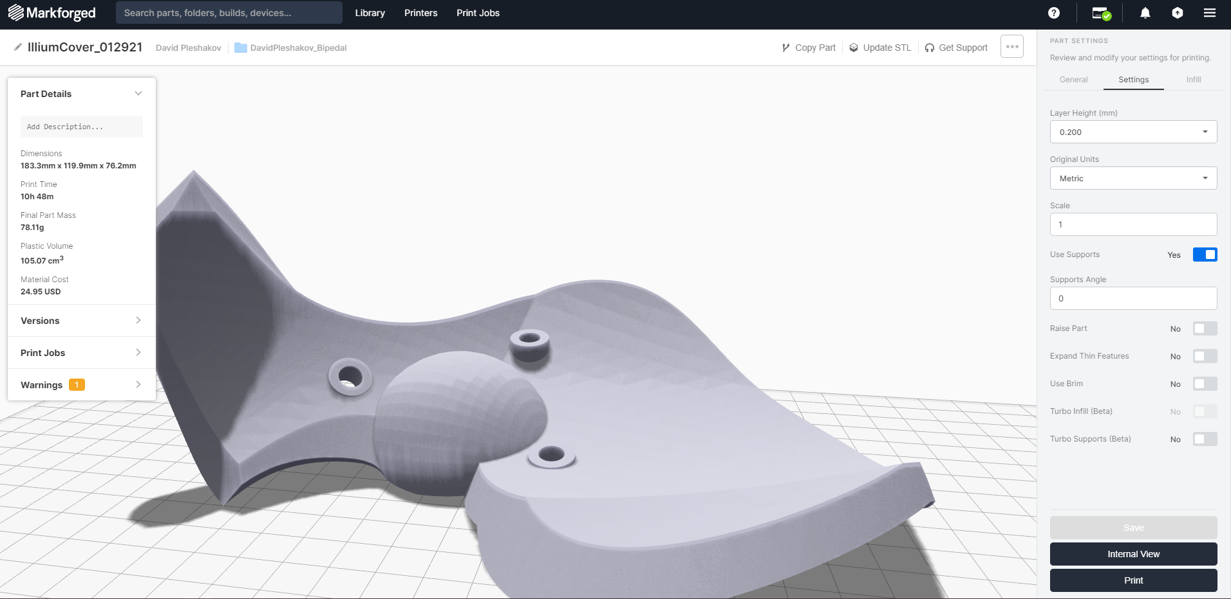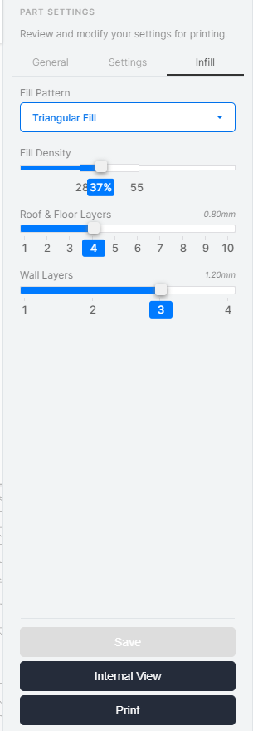

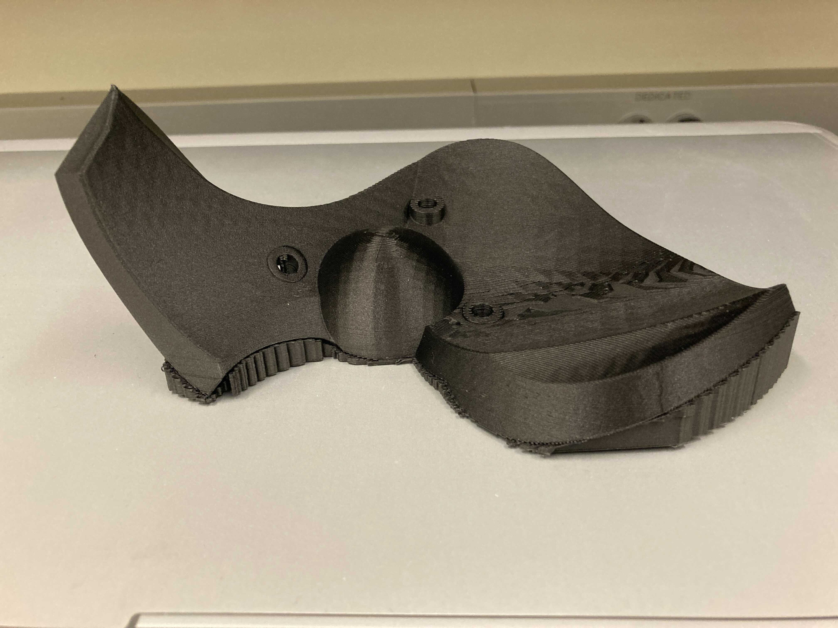

Placed on the flattest bottom part. The part printed well with no issues

## Printing the Femoral Head and Ball

 

